**Find a Doctor, Hospital or health care provider in our network**

* **DocFind** is Aetna’s online provider directory
* Supports **searches for In-Network providers:**
  + - Primary Care Physicians, Specialists and Dentists
    - Hospitals, Facilities and Pharmacies
* Provider data is refreshed six times per week
* **Step 1:** Go to: [www.aetna.com](http://www.aetna,com)\docfind;
* **Step 2:** Under “Continue as a Guest“, enter your 5 digit of zip code, city, state or county and the number of miles you want to look within and click on ‘Search’;
* **Step 3:** After you put in your zip code, city, state or county then “Select a Plan” will appear. Under “Aetna Open Access Plans”, select: Aetna Choice POS II (Open Access) or Aetna Select (Open Choice) depending on what plan you are in; then click ‘Continue’;

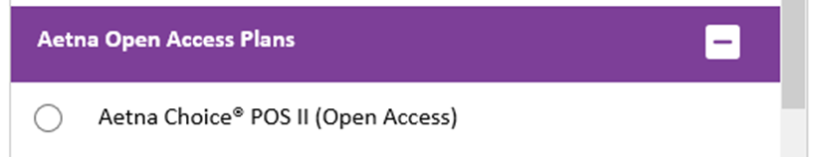

* **Step 4:** Find what you need by category:

